First Name Last Name
Address
City state zip
January 14, 2026

SUBJECT: Forest Street Stormwater construction adjacent to PARCEL

Dear Resident,
In October, the City contacted you to request access to your property to complete survey work related to the stormwater infrastructure drainage issues adjacent to your property.
Following completion of the survey by Spicer Group, the City is planning to install storm sewer piping to collect and convey stormwater along the alignment shown in orange in the image below.
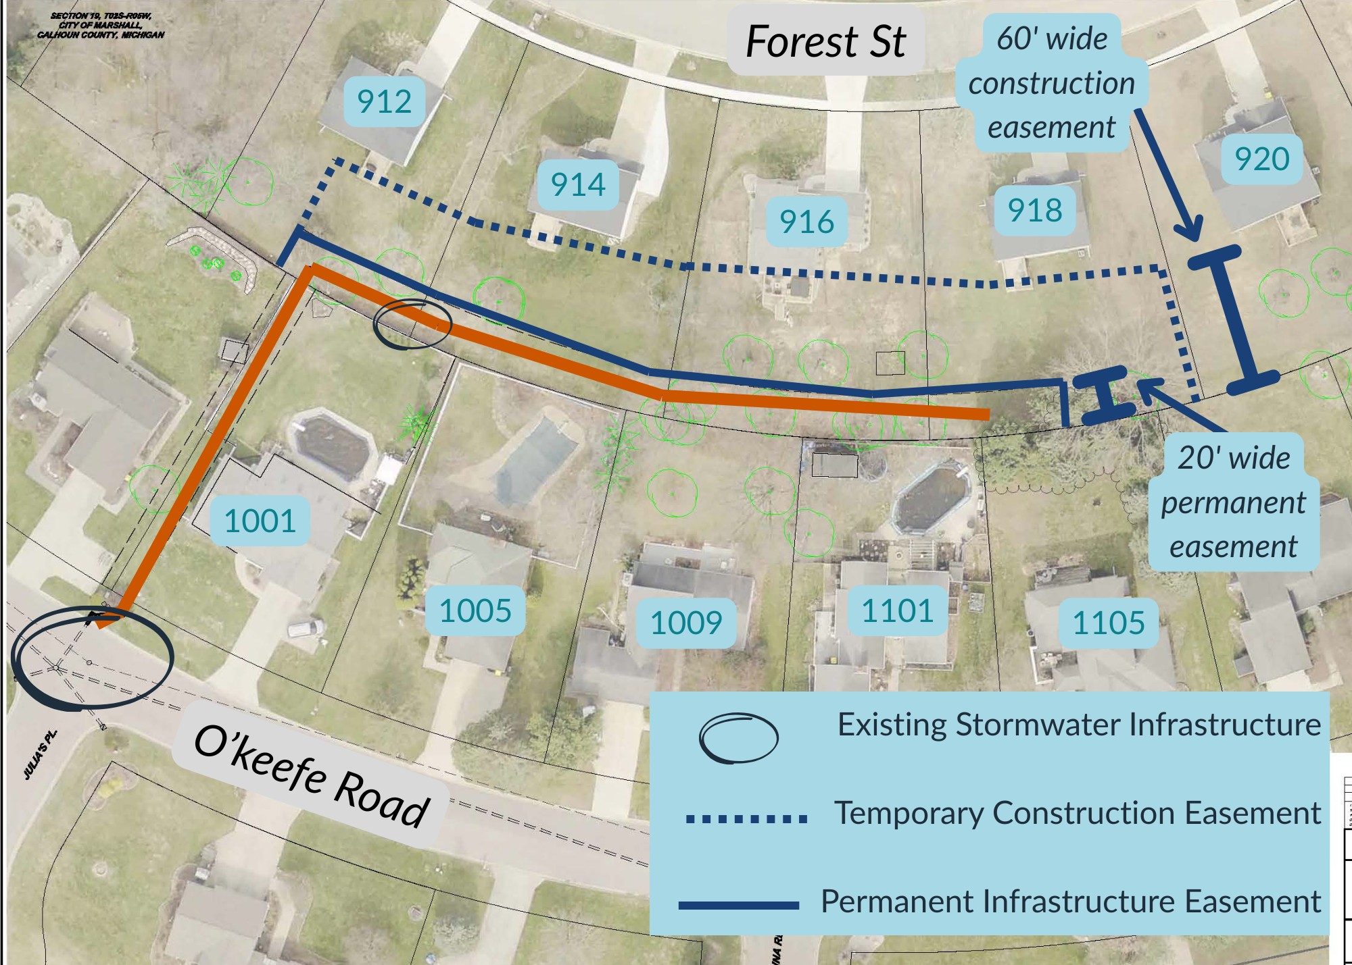
To complete this work, the City will need to obtain permanent stormwater easements and temporary construction easements at some of the addresses in the image above. The temporary
easement is depicted with a dotted line, and the permanent easement is shown with a solid blue line. The proposed infrastructure is represented by the orange line. For address at 912, 914, 916, and 918 Forest and 1001 O’Keefe, the city will be asking for easements in the areas depicted with the solid and dotted blue lines. If your property does not have the orange infrastructure or dark blue easement lines traversing it, this letter is being sent to you for informational purposes only. The City anticipates issuing construction bids as soon as possible, with work expected to begin in spring or summer of this year.
For property owners with easements depicted in the image, the City requests communication regarding your support and agreement to the easements in concept. To help facilitate communication, we request you provided your phone number and email address by contact Linda Urquhart, Public Services Administrative Assistant, at 269-558-0345 or email lurquhart@cityofmarshall.com with your contact information and your agreement to the graphical plan represented. Once initial agreement is obtained and contact information confirmed, the City will share formal easement documents with each property owner that will be specific to each impacted property.
For residents receiving this letter and not directly impacted by easements, we still request your contact information be provided to Linda Urquhart so that we can contact you regarding construction plans and schedules directly.
A webpage on the City’s website has been created for this project at: https://www.cityofmarshall.com/377/Forest-Street-Stormwater-Project. Updates on the project status will be posted to this page. Residents, property owners, and interested community members are also able to sign up for construction specific email or text Notify Me messages on the City’s website at https://www.cityofmarshall.com/list.aspx. We highly recommend registering for the notifications through the website as that is the quickest and most efficient way to receive updates.
Thank you for your cooperation as we are moving forward with this important infrastructure,
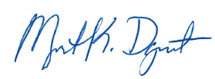
Marguerite Davenport, PE
Director of Public Services
mdavenport@cityofmarshall.com
269-558-0323

