«OWNER_NAME»
«OWNER_MAILING_ADDRS»
«City» «State» «Zip»

October 8, 2025
SUBJECT: City Requests Access to PARCEL «PARCEL» for Survey Activity by Spicer Group

Dear Resident,

The City is requesting access to your property for survey work on Wednesday, October 15, 2025. The City has contracted with our engineer, Spicer Group, to conduct a topographical survey, with the goal of reviewing existing stormwater management controls, in the area. The necessary survey information will be gathered in one day.

The survey work will not require any disturbance to your lawn, garden areas, fences, lawn decorations, or sheds. If small areas are disturbed, they will be restored. The surveyors will be utilizing GPS and laser systems to map the grades and contours of the area. They will be badged employees of Spicer Group and will carry tools including tripods, tablets, levels, or measuring rods. Residents are not required to be home during work unless the area of your property shown in red in the image below is secured behind a fence. Coordination to allow access while you are not home is also an option.

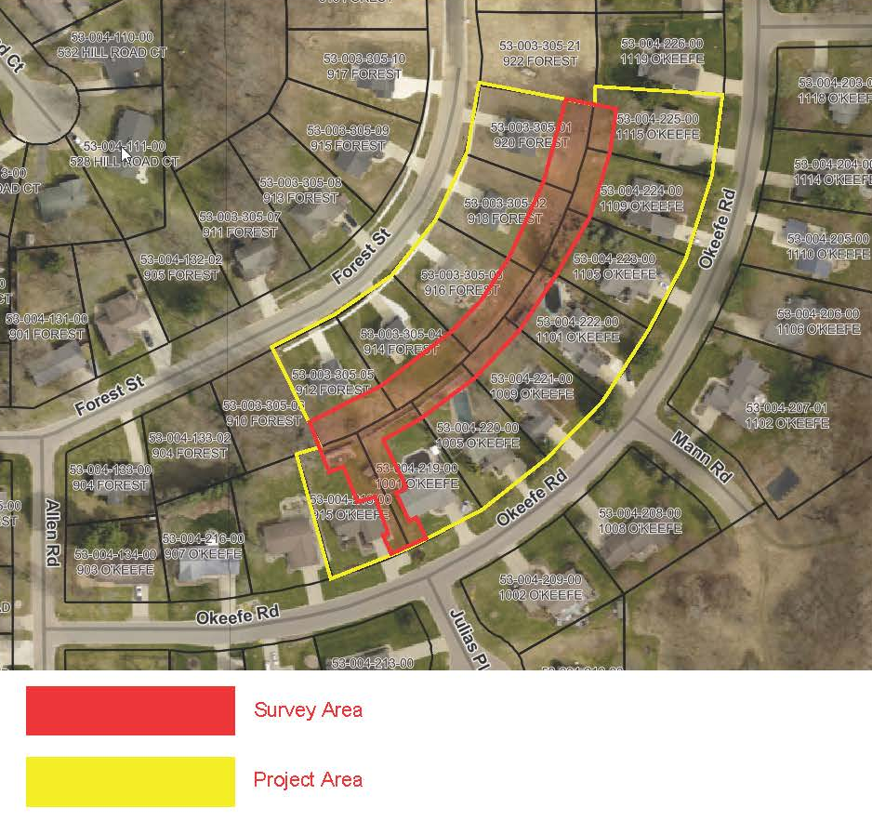
The City greatly appreciates your cooperation during this work. If you do not grant access to the City’s consultant on your property please notify us immediately by emailing myself, Marguerite Davenport at mdavenport@cityofmarshall.com or calling 269-558-0323.

For questions or coordination of property access please contact Spicer Group directly. The contact for the survey work is Dean Wendling, Senior Project Surveyor at 989-224-2355 (office), 989-213-5292 (cell), or deanw@spicergroup.com.

Sincerely,
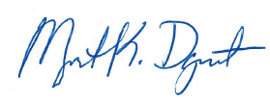

Marguerite Davenport, PE
Director of Public Service
City of Marshall
269-558-0323
mdavneport@cityofmarshall.com

